Step 1: Create React App
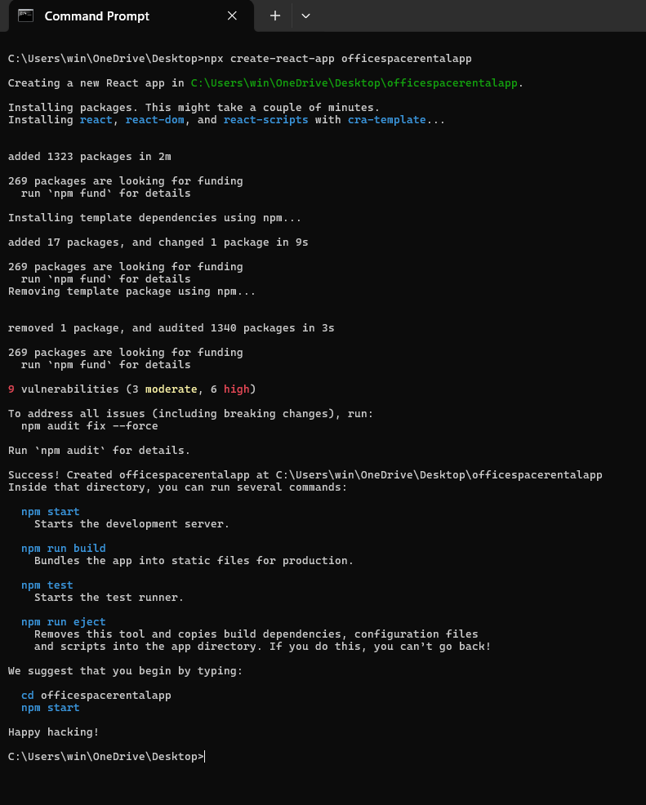
Step 2: Clean the Boilerplate
Inside src, delete unnecessary files like:
App.test.js, logo.svg, reportWebVitals.js, setupTests.js
Update App.js to your custom component.

Step 3: Start Coding
Edit src/App.js as follows:
import React from "react";

// JSX heading element
const heading = <h1>Office Space Rental App</h1>;

// Office image element
const officeImage = "https://imgs.search.brave.com/qEn2pJW9YcD00IwGX7qVmg82HWuP5gvWJdWewFBXIV0/rs:fit:860:0:0:0/g:ce/aHR0cHM6Ly90My5m/dGNkbi5uZXQvanBn/LzAzLzk2LzMwLzg0/LzM2MF9GXzM5NjMw/ODQxN19paFFCZVpU/WGkyTnFrSzZrR0Vs/WHNldUZkNmZBbjVX/TC5qcGc"; // use any image URL
const imageElement = <img src={officeImage} alt="Office" height="200" width="300" />;

// Office object
const office = {
name: "Ocean View Workspaces",
rent: 55000,
address: "Bandra Kurla Complex, Mumbai"
};

// Office list
const officeList = [
{ name: "Ocean View", rent: 55000, address: "Bandra, Mumbai" },
{ name: "Tech Park", rent: 65000, address: "Whitefield, Bangalore" },
{ name: "Skyline Tower", rent: 60000, address: "CyberCity, Gurgaon" }
];

// Component rendering
function App() {
return (
<div style={{ padding: "20px", fontFamily: "Arial" }}>
{heading}
{imageElement}

<h2>Featured Office</h2>
<p><strong>Name:</strong> {office.name}</p>
<p><strong>Rent:</strong> <span style={{ color: office.rent < 60000 ? "red" : "green" }}>{office.rent}</span></p>
<p><strong>Address:</strong> {office.address}</p>

<h2>All Available Offices</h2>
{officeList.map((item, index) => (
<div key={index} style={{ marginBottom: "10px" }}>
<p><strong>Name:</strong> {item.name}</p>
<p>
<strong>Rent:</strong>{" "}
<span style={{ color: item.rent < 60000 ? "red" : "green" }}>{item.rent}</span>
</p>
<p><strong>Address:</strong> {item.address}</p>
<hr />
</div>
))}
</div>
);
}

export default App;

Step4: Run the Project
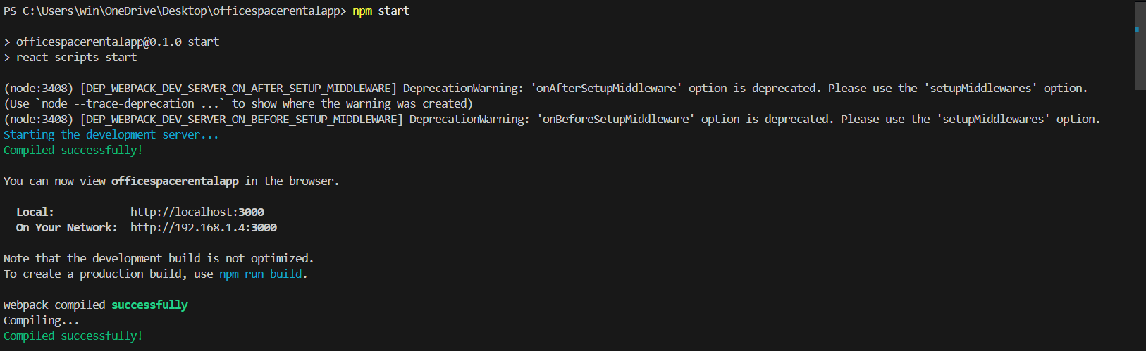
Output:
